**02-02-2018**

**RESEARCH INFOTECH**

**DAILY ANALYSIS**

|  |
| --- |
| http://researchinfotech.co.in/storage/images/logo.pngImage result for SEBI |

|  |
| --- |
| **UJJIVAN FINANCIAL SERVICES LTD (** **NSE:UJJIVAN)** |

|  |  |  |
| --- | --- | --- |
| **BUY** | **380-381** | **SL-365** |
| **TGT 1- 395** | **TGT 2- 415** | **SL-365** |

|  |  |  |  |  |
| --- | --- | --- | --- | --- |
| **S2** | **S1** | **PP** | **R1** | **R2** |
| **320** | **350** | **375** | **400** | **435** |

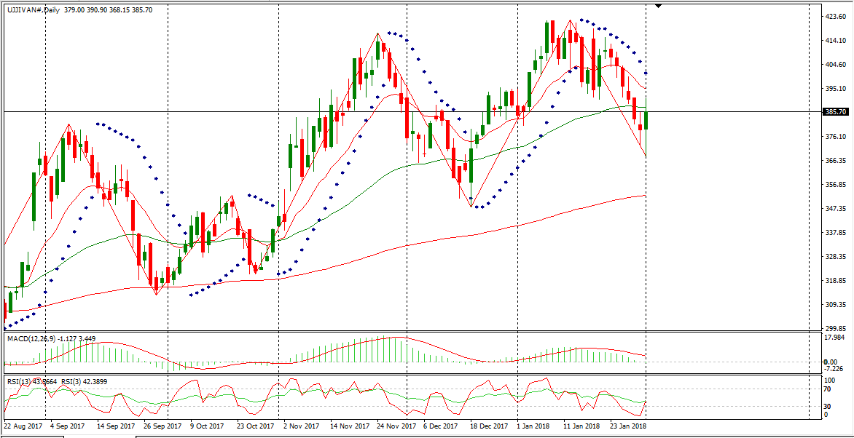

**DESCRIPTION**

Ujjivan Financial Services Limited, formerly Ujjivan Financial Services Private Limited, is a non-banking finance company engaged in the micro finance lending business.   
The Company's products and services include Microfinance, Micro and Small Enterprise Business (MSE) Finance, Agriculture and Animal Husbandry Finance, and Housing Finance.  
 Its products are classified under two categories: Group Loans and Individual Loans. Its products are further sub-divided into agricultural, education, home improvement, home purchase and livestock loans. MSE and Housing loans are both secured and unsecured loan products, which are available for both existing and open market customers.   
It serves economically poor in urban and semi urban areas. Through its partnership with Bajaj Allianz Life Insurance Company, it offers life insurance to its customers and their spouses. It operates through approximately 470 branches spread over 20 states in approximately four regions: South, East, North and West.

|  |
| --- |
| http://researchinfotech.co.in/storage/images/logo.pngImage result for SEBI |

**TECHNICAL VIEW**

* In daily candle UJJIVAN was looking strong, it was taking support of its 200 day’s EMA and looking reversal.
* From the opening it was falling down but near closing continuous fresh buying it took support of its short term moving average and I saw fresh buying near closing.
* In short term its structure was also looking bullish and taking support of its 14 day’s EMA also.
* In daily candle made bullish hammer and tend to reversal, next trading it can be gap up opening.
* Above its moving avg it made a bullish candle in daily candle stick chart pattern.
* Its daily candle it was making bearish candle and today I saw it made bullish candle and from the bottom I fresh buying also.

**RECENT NEWS**

* Shares of Ujjivan Financial Services Limited (UJJIVAN.NS) touched a high of 390.35 and dipped down to a low of 380.50 before settling at 382.40 in the most recent session.   
  The stock has experienced bearish momentum as it’s ATR or Average True Range has dipped consistently over the past 10 sessions.
* Currently, the 14-day ADX for Ujjivan Financial Services Limited (UJJIVAN.NS) is sitting at 13.84. Generally speaking, an ADX value from 0-25 would indicate an absent or weak trend.   
  A value of 25-50 would support a strong trend. A value of 50-75 would identify a very strong trend, and a value of 75-100 would lead to an extremely strong trend.  
  ADX is used to gauge trend strength but not trend direction.   
  Traders often add the Plus Directional Indicator (+DI) and Minus Directional Indicator (-DI) to identify the direction of a trend.
* Investors may be watching other technical indicators such as the Williams Percent Range or Williams %R.   
  The Williams %R is a momentum indicator that helps measure oversold and overbought levels.   
  This indicator compares the closing price of a stock in relation to the highs and lows over a certain time period. A common look back period is 14 days.  
   Ujjivan Financial Services Limited (UJJIVAN.NS)’s Williams %R presently stands at -95.49. The Williams %R oscillates in a range from 0 to -100. A reading between 0 and -20 would indicate an overbought situation. A reading from -80 to -100 would indicate an oversold situation.

## **DISCLOSURE**

RESEARCH INFOTECH DO NOT RECEIVE ANY CONSIDERATION BY WAY OF REMUNERATION OR COMPENSATION OR IN ANY OTHER FORM WHATSOEVER, BY US OR ANY OF OUR ASSOCIATES OR SUBSIDIARIES FOR ANY DISTRIBUTION OR EXECUTION SERVICES IN RESPECT OF THE PRODUCTS OR SECURITIES FOR WHICH THE INVESTMENT ADVICE IS PROVIDED TO THE CLIENT.

RESEARCH INFOTECH DO NOT RECOMMEND A STOCK/COMMODITY BROKER. IF ANY STOCK/COMMODITY BROKER IS RECOMMENDED BY ANY OF OUR REPRESENTATIVE, WE DO NOT RECEIVE ANY CONSIDERATION BY WAY OF REMUNERATION OR COMPENSATION OR IN ANY OTHER FORM WHATSOEVER FROM STOCK/COMMODITY BROKER OR ANY OTHER INTERMEDIARY SO RECOMMENDED TO CLIENT.

TO ENSURE COMPLIANCE WITH THE INVESTMENT ADVISOR REGULATIONS 2013, WE HAVE RESOLVED THAT THE INVESTMENT ADVISOR AND ALL ITS REPRESENTATIVES WILL NOT MAKE ANY TRADES IN THE MARKET. WE ARE NOT ASSOCIATED IN ANY MANNER WITH ANY ISSUER OF PRODUCTS/ SECURITIES, THIS ENSURES THAT THERE IS NO ACTUAL OR POTENTIAL CONFLICTS OF INTEREST. THIS ALSO ENSURES THAT OBJECTIVITY OR INDEPENDENCE IN THE CARRYING ON OF INVESTMENT ADVISORY SERVICES IS NOT COMPROMISED. INVESTMENT IN STOCK/COMMODITY MARKETS IS SUBJECT TO MARKET RISK, THOUGH BEST ATTEMPTS ARE MADE FOR PREDICTING MARKETS, BUT NO SURETY OF RETURN OR ACCURACY OF ANY KIND IS GUARANTEED, WHILE THE PERFORMANCE SHEET OF VARIOUS PRODUCTS IS AVAILABLE BUT SHOULD NOT BE CONSIDERED AS A GUARANTEE FOR FUTURE PERFORMANCE OF THE PRODUCTS/SERVICES. CLIENTS ARE ADVISED TO CONSIDER ALL THE ADVICE AS JUST AN OPINION AND MAKE INVESTMENT DECISION ON THEIR OWN.

IN CASE OF CLIENTS SEEKING ADVICE ON ANY SPECIFIC POSITIONS ALREADY MADE BY THE CLIENT, WE WILL BE ABLE TO SUGGEST BEST POSSIBLE ACTION CONSIDERING OUR VIEW ON THE SECURITY OR PRODUCT. SUCH SUGGESTION UNDER ANY CIRCUMSTANCES SHALL BE CONSIDERED AS AN OPINION (NOT ADVICE) FROM OUR ORGANIZATION AND WE ADVISE CLIENT TO CONSIDER OUR OPINION AND NOT CONSULTANCY TO MAKE HIS/HER FINAL DECISION. WE ARE NOT LIABLE FOR ANY LOSSES WHATSOEVER CLIENT MAY INCUR IN ACCEPTING THIS OPINION.

CLIENT IS ALSO ADVISED TO TRADE ONLY IF TIPS SUIT HIS CURRENT RISK APPETITE AND RISK BEARING CAPACITY, ALL SUCH TIPS SHALL BE CONSIDERED AS A VIEW OR OPINION AND CLIENT SHALL ON HIS/HER DISCRETION DECIDE ACTUAL TRADES.

WE ARE NOT ASSOCIATED WITH ANY INTERMEDIARIES AND DO NOT RECOMMEND SERVICES OF ANY SPECIFIC INTERMEDIARIES.  
NO LITIGATIONS HAVE BEEN FILED AGAINST US SINCE THE INCORPORATION.

ALL THE TIPS WHICH ARE SUGGESTED BY US ARE COMMUNICATED IN WRITTEN, NO VERBAL COMMUNICATION FROM ANY OF THE EXECUTIVES OR OTHERWISE UNDER ANY CIRCUMSTANCES SHALL BE CONSIDERED AS ADVICE BY OUR ORGANIZATION.